**CREDIT CARD FRAUD DETECTION**

*Project report submitted*

*in partial fulfillment of the requirement for award of the degree of*

# **Bachelor of Technology**

# **in**

**Computer Science and Engineering**

**by**

|  |  |
| --- | --- |
| **L. GANESH SATYA** | **(U21CS431)** |
| **M.V.S.R.REDDY** | **(U21CS442)** |
| **M.T.S.MANIKANTA** | **(U21CS451)** |
| **M.VIVEK** | **(U21CS452)** |

*Under the guidance of*

## **Dr.Mrs.K.SATHYA PRIYA**



**DEPARTMENT OF COMPUTER SCIENCE AND ENGINEERING SCHOOL OF COMPUTING**

**BHARATH INSTITUTE OF HIGHER EDUCATION AND RESEARCH**

**(Deemed to be University Estd u/s 3 of UGC Act, 1956)**

## **CHENNAI 600073, TAMILNADU, INDIA**

**March, 2025**

**CERTIFICATE**

This is certified that the work contained in the project report titled “**CREDIT CARD FRAUD DETECTION”** by “L. GANESH SATYA (U21CS431), M.V.S.R.REDDY(U21CS442), M.T.S.MANIKANTA (U21CS451), M.VIVEK (U21CS452)” to the Department of Computer Science and Engineering, Bharath Institute of Higher Education and Research, in partial fulfillment for the award of the degree of B. Tech in (Computer Science and Engineering) is a bona fide record of project work carried out by them under my supervision. The contents of this report, in full or in parts, have not been submitted to any other Institution or University for the award of any other degree.

**Signature of the Supervisor**

**Dr.Mrs.K.Sathiya Priya**

**Computer Science & Engineering**

**School of Computing**

**Bharath Institute of Higher Education and Research**

**March, 2025**

**Signature of Head of the Department**

**Dr. B. Persis Urbana Ivy**

**Professor & Head**

**Computer Science & Engineering**

**School of Computing Bharath Institute of Higher Education and Research**

**March, 2025**

# **DECLARATION**

We declare that this project report titled **“Credit card Fraud Detection”** submitted in partial fulfillment of the degree of **B.Tech in (Computer Science and Engineering)** is a record of original work carried out by us under the supervision of **Dr.Mrs.K.Sathiya Priya** and has not formed the basis for the award of any other degree or diploma, in this or any other Institution or University. In keeping with the ethical practice in reporting scientific information, due acknowledgements have been made wherever the findings of others have been cited.

(Signature)

(L. Ganesh Satya

U21CS431)

(Signature)

(M.V.S.Reddy

U21CS442)

(Signature)

(M.Manikanta

U21CS451)

(Signature)

(M.Vivek

U21CS452)

**Chennai**

**Date: 23/ 03 /2025**

**ACKNOWLEDGMENT**

First, we wish to thank the almighty who gave us good health and success throughout our project work.

We express our deepest gratitude to our beloved President **Dr. J. Sundeep Aanand,** and Managing Director **Dr.E. Swetha Sundeep Aanand** for providing us the necessary facilities for the completion of our project.

We take great pleasure in expressing sincere thanks to Vice Chancellor **Dr. K. Vijaya Baskar Raju**, Pro Vice Chancellor (Academic) **Dr. M. Sundararajan**, Registrar **Dr. S. Bhuminathan**

and Additional Registrar **Dr. R. Hari Prakash** for backing us in this project.

We thank our Dean Engineering **Dr. J. Hameed Hussain** for providing sufficient facilities for the completion of this project.

We thank our Dean, School of Computing **Dr. S. Neduncheliyan** for his encouragement and the valuable guidance throughout the project.

We record indebtedness to our Head, Department of Computer Science and Engineering Dr**. B. Persis Urbana Ivy** for immense care and encouragement towards us throughout the course of this project.

A special thanks to our Project Coordinators **Dr.A. Sinduja** for her valuable guidance and support throughout the course of the project.

We also take this opportunity to express a deep sense of gratitude to our Internal Supervisor **Dr.Mrs.K.Sathiya Priya** for her cordial support, valuable information and guidance, he helped us in completing this project through various stages.

We thank our department faculty, supporting staff and friends for their help and guidance to complete this project.

|  |  |
| --- | --- |
| **L. GANESH SATYA** | **(U21CS431)** |
| **M.V.S.R.REDDY** | **(U21CS442)** |
| **M.T.S.MANIKANTA** | **(U21CS451)** |
| **M.VIVEK** | **(U21CS452)** |

**Abstract**

This Project is focused on credit card fraud detection in RealWorld scenarios. Nowadays credit card frauds are drastically increasing in number as compared to earlier times. Criminals are using fake identity and various technologies to trap the users and get the money out of them. Therefore, it is very essential to find a solution to these types of frauds. In this proposed project we designed a model to detect the fraud activity in credit card transactions. This system can provide most of the important features required to detect illegal and illicit transactions. As technology changes constantly, it is becoming difficult to track the behavior and pattern of criminal transactions. To come up with the solution one can make use of technologies with the increase of machine learning, artificial intelligence and other relevant fields of information technology, it becomes feasible to automate this process and to save some of the intensive amounts of labor that is put into detecting credit card fraud. Initially, we will collect the credit card usage data-set by users and classify it as trained and testing dataset using a random forest algorithm and decision trees. Using this feasible algorithm, we can analyze the larger data-set and user provided current data-set. Then augment the accuracy of the result data. Proceeded with the application of processing of some of the attributes provided which can find affected fraud detection in viewing the graphical model of data visualization. The performance of the techniques is gauged based on accuracy, sensitivity, and specificity, precision. The results are indicated concerning the best accuracy for Random Forest are unit 98.6% respectively.

**LIST OF FIGURES**

**Fig No.** **Fig Name** **Page No**

Fig.6.1 ARCHITECTURE OF THE PROPOSED SYSTEM

Fig. 8.1.1.1 Importing python packages for data exploration,

pre-processing and for using random forest algorithm.

Fig: 8.3.1.1 Data exploration

Fig. 8.3.1.2 Pre-processing

Fig: 8.3.1.3 Pre-processing Step 2

Fig.8.3.1.4 Training and testing data

Fig. 8.3.1.5: Process of training and testing data extraction

Fig. 9.1.1.1 Confusion matrix for testing dataset

Fig. 9.1.1.2: Confusion matrix for testing dataset

Fig. 9.1.1.3: Accurate result extracted from the random forest

**ABBREVIATIONS/ NOTATIONS/ NOMENCLATURE**

* **FP**: False Positive
* **FN**: False Negative
* **TN**: True Negative
* **TP --** True Positive
* **ML** -- Machine Learning

**TABLE OF CONTENTS**

**DESCRIPTION PAGE NUMBER**

CERTIFICATE i

DECLARATION ii

ACKNOWLEDGEMENTS 4

ABSTRACT 5

LIST OF FIGURES 6

LIST OF TABLES 7

ABBREVIATIONS/ NOTATIONS/ NOMENCLATURE 8

1. INTRODUCTION 9
   1. Aim of the project
   2. Scope of the Project
   3. Methodology
2. LITERATURE SURVEY 12  
    a) Comprehensive Analysis for Fraud Detection of Credit Card through Machine Learning

b) Credit Card Fraud Detection Using Various Classification and

Sampling Techniques

c) Credit Card Fraud Detection: A classification analysis

d) Credit card fraud detection with a neural-network

e) A Credit Card Fraud Detection Techniques

f) Credit card fraud detection using artificial neural network

1. EXISTING SYSTEM AND PROPOSED SYSTEM
   1. Existing System
   2. Proposed System
2. HARDWARE AND SOFTWARE REQUIREMENTS
   1. Requirements Specification
   2. Hardware Requirements
   3. Software Requirements
3. FEASIBILITY STUDY
   1. Technical Feasibility
   2. Economical Feasibility
   3. Fianacial Feasibility
4. SYSTEM ARCHITECTURE
5. PACKAGES
6. SYSTEM MODULES
   1. Modules

8.1.1. Data collection

* 1. Data pre-processing
  2. Data exploration
  3. Data visualization
  4. Feature extraction
  5. Evaluation model

1. ALGORHIM
   1. Random forest

9.1.1. Advantages of using random forest

1. CONCLUSION

**Reference**

**Chapter – 1**

**Introduction**

Credit card fraud is a huge ranging term for theft and fraud committed using or involving at the time of payment by using this card. The purpose may be to purchase goods without paying, or to transfer unauthorized funds from an account. Credit card fraud is also an add on to identity theft. As per the information from the United States Federal Trade Commission, the theft rate of identity had been holding stable during the mid 2000s, but it was increased by 21 percent in 2008. Even though credit card fraud, that crime which most people associate with ID theft, decreased as a percentage of all ID theft complaints in 2000, out of 13 billion transactions made annually, approximately 10 million or one out of every 1300 transactions turned out to be fraudulent.

Also, 0.05% (5 out of every 10,000) of all monthly active accounts was fraudulent. Today, fraud detection systems are introduced to control one-twelfth of one percent of all transactions processed which still translates into billions of dollars in losses. Credit Card Fraud is one of the biggest threats to business establishments today. However, to combat the fraud effectively, it is important to first understand the mechanisms of executing a fraud. Credit card fraudsters employ a large number of ways to commit fraud. In simple terms, Credit Card Fraud is defined as “when an individual uses another individuals’ credit card for personal reasons while the owner of the card and the card issuer are not aware of the fact that the card is being used”. Card fraud begins either with the theft of the physical card or with the important data associated with the account, including the card account number or other information that necessarily be available to a merchant during a permissible transaction. Card numbers generally the Primary Account Number (PAN) are often reprinted on the card, and a magnetic stripe on the back contains the data in machine-readable format. It contains the following Fields:

* **Name of card holder**
* **Card number**
* **Expiration date**
* **Verification/CVV code**
* **Type of card**

There are more methods to commit credit card fraud. Fraudsters are very talented and fast-moving people. In the Traditional approach, to be identified by this paper is Application Fraud, where a person will give the wrong information about himself to get a credit card. There is also the unauthorized use of Lost and Stolen Cards, which makes up a significant area of credit card fraud. There are more enlightened credit card fraudsters, starting with those who produce Fake and Doctored Cards; there are also those who use Skimming to commit fraud. They will get this information held on either the magnetic strip on the back of the credit card, or the data stored on the smart chip is copied from one card to another. Site Cloning and False Merchant Sites on the Internet are getting a popular method of fraud for many criminals with a skilled ability for hacking. Such sites are developed to get people to hand over their credit card details without knowing they have been swindled.

**1.1 Aim of the project:**

We propose a Machine learning model to detect fraudulent credit card activities in online financial transactions. Analyzing fake transactions manually is impracticable due to vast amounts of data and its complexity. However, adequately given informative features, could make it is possible using Random Forest Algorithm in Machine Learning.

**1.2 Scope of this Project:**

In this proposed project we designed a protocol or a model to detect the fraud activity in credit card transactions. This system is capable of providing most of the essential features required to detect fraudulent and legitimate transactions. As technology changes, it becomes difficult to track the behavior and pattern of fraudulent transactions. With the upsurge of machine learning, artificial intelligence and other relevant fields of information technology, it becomes feasible to automate the process and to save some of the effective amount of labor that is put into detecting credit card fraudulent activities.

**1.3 Methodology:**

We propose a Machine learning model to detect fraudulent credit card activities in online financial transactions. Analyzing fake transactions manually is impracticable due to vast amounts of data and its complexity. However, adequately given informative features, could make it is possible using Machine Learning. This hypothesis will be explored in the project. To classify fraudulent and legitimate credit card transaction by supervised learning Algorithm such as Random Forest. To help us to get awareness about the fraudulent and without loss of any financially.

**Chapter 2**

**Literature Survey:**

Billions of dollars of loss are caused every year by the fraudulent credit card transactions. Fraud is old as humanity itself and can take an unlimited variety of different forms. The PwC global economic crime survey of 2017 suggests that approximately 48% of organizations experienced economic crime. Therefore, there is definitely an urge to solve the problem of credit card fraud detection. Moreover, the development of new technologies provides additional ways in which criminals may commit fraud. The use of credit cards is prevalent in modern day society and credit card fraud has been kept on growing in recent years. Hugh Financial losses has been fraudulent affects not only merchants and banks, but also individual person who are using the credits. Fraud may also affect the reputation and image of a merchant causing non-financial losses that, though difficult to quantify in the short term, may become visible in the long period. For example, if a cardholder is victim of fraud with a certain company, he may no longer trust their business and choose a contender.

1. **Comprehensive Analysis for Fraud Detection of Credit Card through Machine Learning**

* **Year:** 2021
* **Authors:** Parth Roy; Prateek Rao; Jay Gajre; Kanchan Katake; Arvind Jagtap
* **Content:** 
  + - Explains about different Machine learning algorithms in detecting credit card transactions
    - Only theory is presented but not the actual idea to implement those Machine learning algorithm

**b. Credit Card Fraud Detection Using Various**    **Classification and Sampling Techniques**

* **Year:** 2020
* **Authors:** J. V. V. Sriram Sasank; G. Ram Sahith; K. Abhinav; Meena Belwal
* **Content:**
  + - Explains about different Machine learning algorithms in detecting credit card transactions
    - Implementation of theory to practical method can be observe but didn’t provide enough output and didn’t have much exposer to the real datasets.

**c. Credit card fraud detection with a neural-network**

* **Year:** 2020
* **Authors:** Ghosh; Reilly
* **Content:**
  + - Explains about different Machine learning algorithms in detecting credit card transitions
    - In this paper they also used Artificial neural networks as like a mini-AI to train the system
    - It has been successful but the has required huge resources and perform the tasks

**d. Credit Card Fraud Detection: A classification analysis**

* **Year:** 2018
* **Authors:** Sonali Baksh
* **Content:**
  + - Proposed about the unreal and fake credit cards that are present in the cyber world
    - In this paper it is explained that the fake cards and fake money transactions can easily done without much detection until it is too late
    - In this paper it has provided few examples and different analysis by using unsupervised learning techniques to find the real ones form the fake ones.

**e. Credit card fraud detection using artificial neural network**

* **Year:** 2020
* **Author:** Asha RB; Suresh Kumar KR
* **Content:** 
  + - Explains about different Machine learning algorthims in detecting credit card transations using with artifical neural networks with large datasets of credit card data
    - In this the training the machine is taking place unsupervised learning and the data is used must be high accuracy

**f. A Credit Card Fraud Detection Techniques**

* **Year:** 2021
* **Author:** Kshitij Pandey; Piyush Sachan; Shakti; Nikam Gitanjali Ganpatrao
* **Content:** 
  + Explains about different Machine learning algorithms in detecting credit card transactions
  + Only theory is presented but not the actual idea to implementation those Machine learning algorithm and not and actual practical approach

**Chapter 3**

**Existing System and Proposed System**

**3.1 Existing System:**

* In existing System, research about a case study involving credit card fraud detection, where data normalization is applied before Cluster Analysis and with results obtained from the use of Cluster Analysis and Artificial Neural Networks on fraud detection has shown that by clustering attributes neuronal inputs can be minimized.
* The data set for this paper is based on real life transactional data by a large European company and personal details in data is kept confidential. Accuracy of an algorithm is around 50%. In existing system methods such as Cluster Analysis, Bayesian network, Logistic Regression, Naïve Bayer’s, Hidden Markov model etc. are used to find out the credit card fraud transactions.
* The methods used in the existing system are based on unsupervised learning and the accuracy obtained by these methods is about 60-70%.

**3.2. Proposed System:**

* In proposed System, we are applying random forest algorithm for classification of the credit card dataset. Random Forest is an algorithm for classification and regression.
* Summarily, it is a collection of decision tree classifiers. Random forest has advantage over decision tree as it corrects the habit of over fitting to their training set.
* A subset of the training set is sampled randomly so that to train each individual tree and then a decision tree is built, each node then splits on a feature selected from a random subset of the full feature set.
* Even for large data sets with many features and data instances training is extremely fast in random forest and because each tree is trained independently of the others. The Random Forest algorithm has been found to provide a good estimate of the generalization error and to be resistant to over fitting.
* Supervised learning using Random Forest machine learning algorithm.
* The proposed system overcomes the above-mentioned issue in an efficient way. It aims at analysing the number of frauds of fraud transactions that are present in the dataset. In proposed System, we use Random Forest algorithm to classify the credit card dataset.

**Chapter 4**

**Hardware and Software**

**4.1 Requirements Specification:**

* The requirements specification is a technical specification of requirements for the software products. It is the first step in the requirements analysis process it lists the requirements of a particular software system including functional, performance and security requirements. The purpose of software requirements specification is to provide a detailed overview of the software project, its parameters and goals.

**4.2 HARDWARE REQUIREMENTS**

* Processor - Intel R
* RAM - 4 Gb
* Hard Disk - 260 GB
* Key Board - Standard Windows Keyboard
* Mouse - Two or Three Button Mouse

**4.3 SOFTWARE REQUIREMENTS:**

* Python
* Anaconda
* OS - Windows 7, 8 ,10and 11 (32 and 64 bit)

**Chapter - 5**

**5. FEASIBILITY STUDY:**

**5.1 TECHNICAL FEASIBILITY**

* It is evident that necessary hardware and software are available for development and implementation of proposed system.
* It uses Anaconda.

**5.2 ECONOMICAL FEASIBILITY**

* The cost for the proposed system is comparatively less to other existing software’s.

**5.3 OPERATIONAL FEASIBILITY**

* In this project it requires to configure the necessary software to work on the software.

**Chapter - 6**

**6. SYSTEM ARCHITECTURE:**

First the credit card dataset is taken from the source and cleaning and validation is performed on the dataset which includes removal of redundancy, filling empty spaces in columns, converting necessary variable into factors or classes then data is divided into 2 parts, one is training dataset and another one is test data set. Now the original sample is randomly partitioned into teat and train dataset.

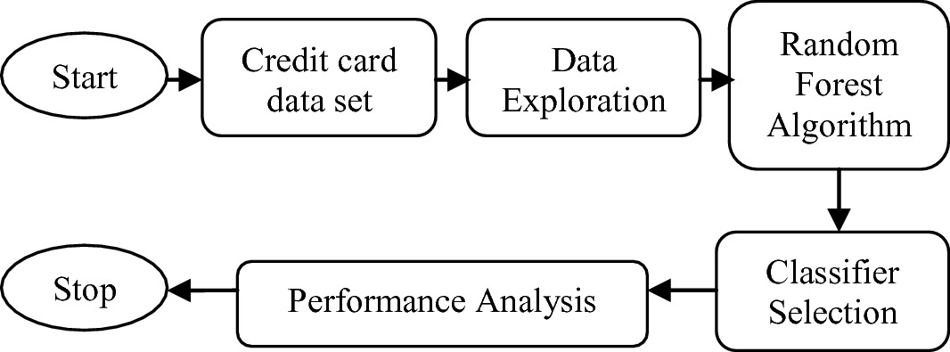 Figure 6.1- ARCHITECTURE OF THE PROPOSED SYSTEM

**Chapter - 7**

**7.**  **Packages:**

Which are being used for data exploration, pro processing and for using random forest algorithm are:

* NumPy: For simple arrays.
* Pandas: For reading the file.
* SciKit: Learn- for pre-processing.
* Matplotlib or Seaborn: For plotting and representing confusion matrix colour format.
* Tensor flow: For matrix format.

**Chapter – 8**

**8. SYSTEM MODULES:**

**8.1 MODULES:**

* Data collection
* Data pre-processing
* Feature extraction
* Evaluation model

**8.1.1 Data collection:**

Data used in this paper is a set of product reviews collected from credit card transactions records. This step is concerned with selecting the subset of all available data that you will be working with. ML problems start with data preferably, lots of data (examples or observations) for which you already know the target answer. Data for which you already know the target answer is called labelled data.

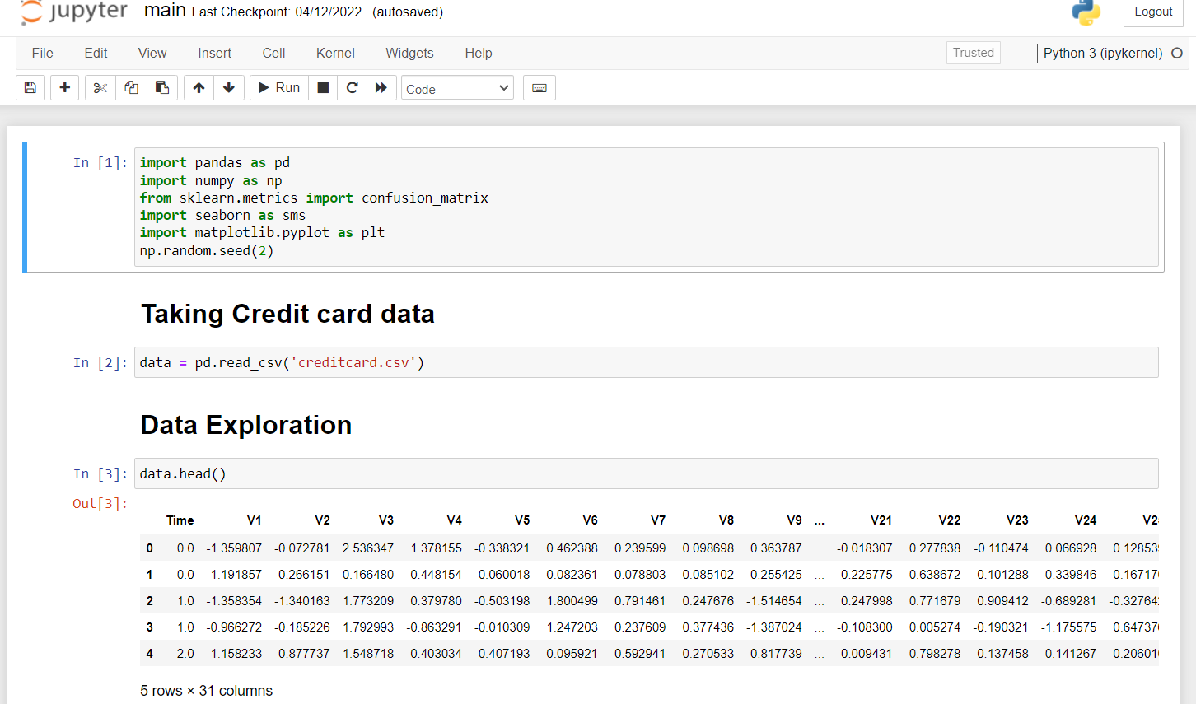 Fig. 8.1.1.1: Importing python packages for data exploration, pre-processing and for using random forest algorithm.

**8.2 Data pre-processing:**

Pre-processing is the process of three important and common steps as follows:

* Formatting: It is the process of putting the data in a legitimate way that it would be suitable to work with. Format of the data files should be formatted according to the need. Most recommended format is .csv files.
* Cleaning: Data cleaning is a very important procedure in the path of data science as it constitutes the major part of the work. It includes removing missing data and complexity with naming category and so on. For most of the data scientists, Data Cleaning continues of 80% of work.
* Sampling: This is the technique of analysing the subsets from whole large datasets, which could provide a better result and help in understanding the behaviour and pattern of data in an integrated way.

**8.3 Data exploration:**

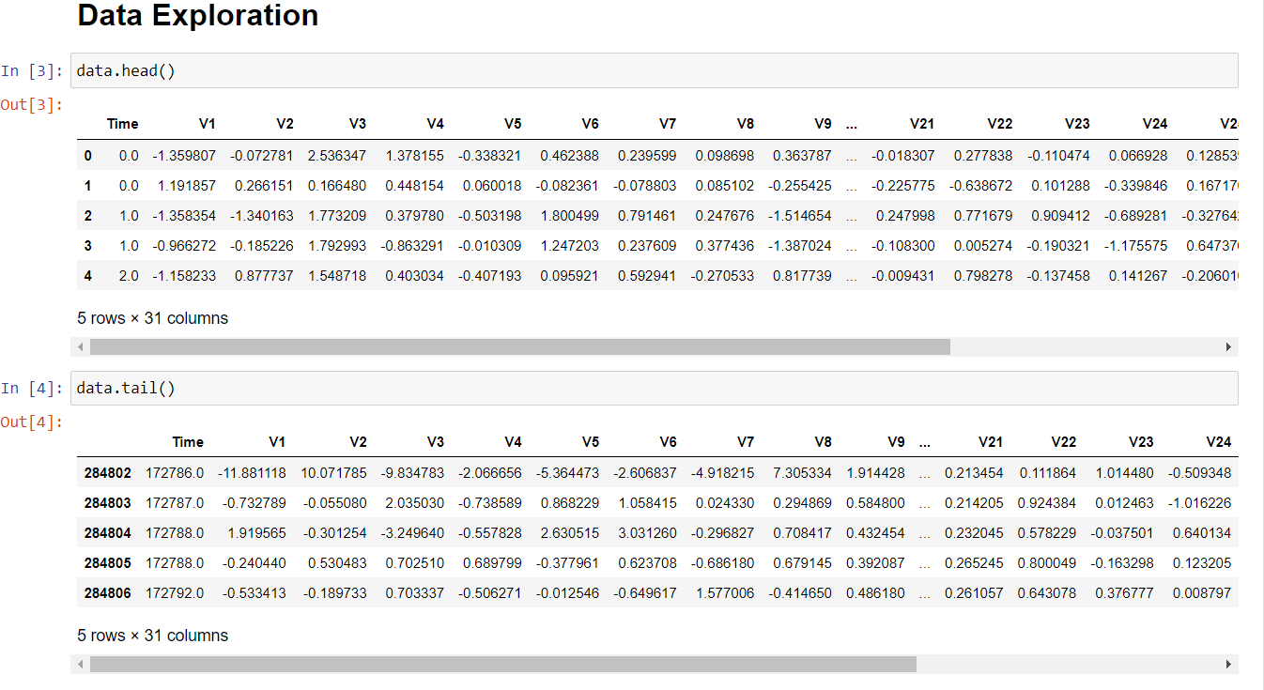 Fig: 8.3.1.1: Data exploration

**8.3.1 Pre-processing with python commands:**

**Step 1:**

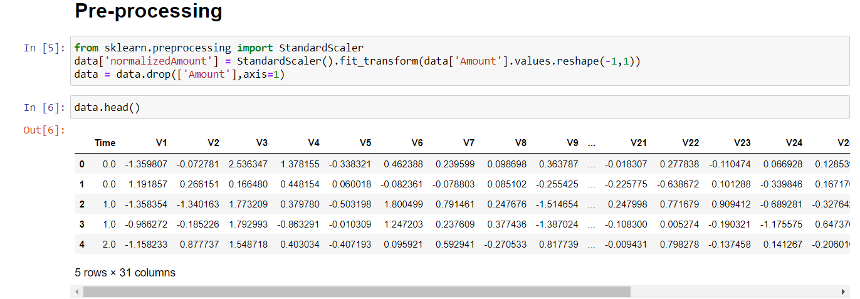 Fig. 8.3.1.2: Pre-processing

**Step 2:**

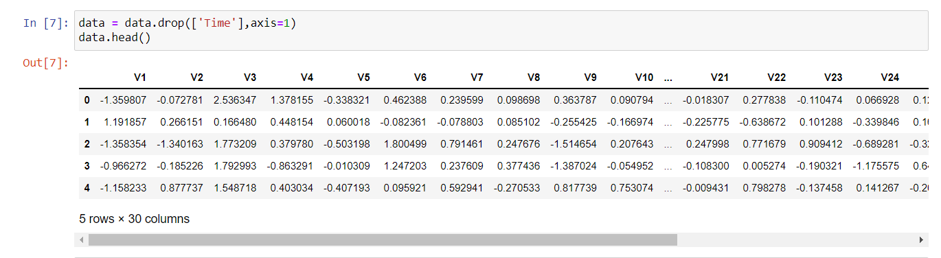 Fig: 8.3.1.3: Pre-processing Step 2

**Step 3: Acquired trained and testing dataset from the large dataset**

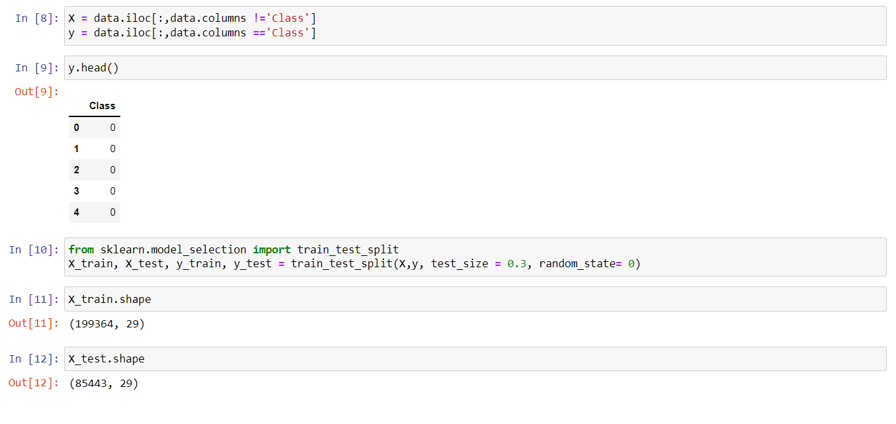 Fig.8.3.1.4: Training and testing data

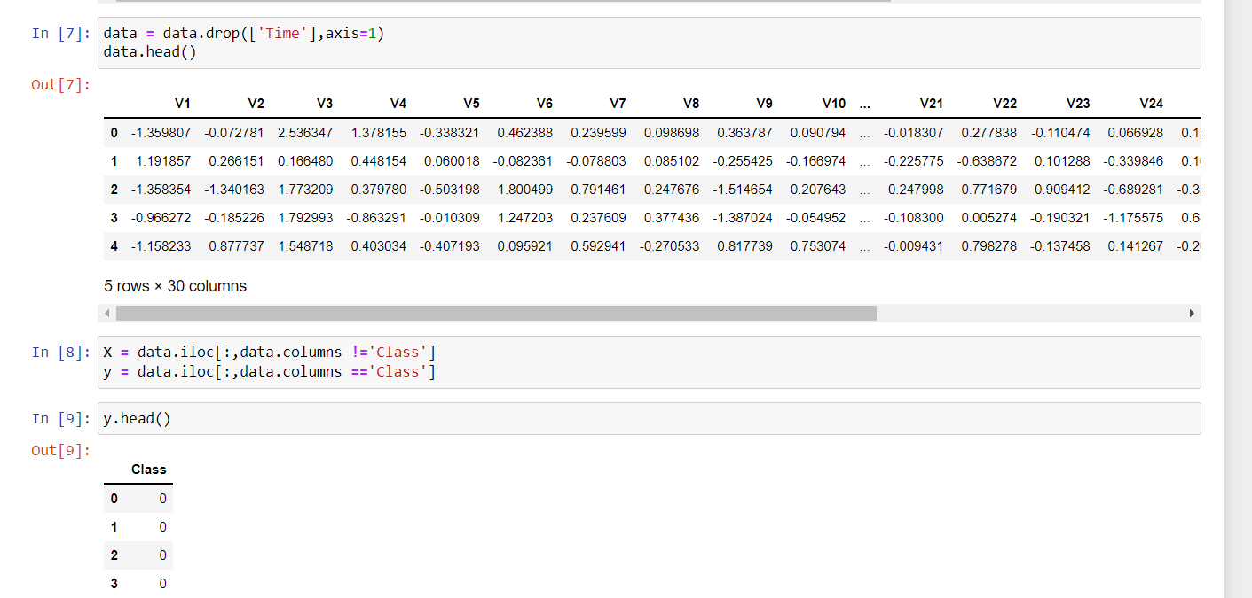 Fig. 8.3.1.5: Process of training and testing data extraction

**8.4 Data visualization:**

Data Visualisation is the method of representing the data in a graphical and pictorial way, data scientists depict a story by the results they derive from analysing and visualising the data. The best tool used is Tableau which has many features to play around with data and fetch wonderful results.

**8.5 Feature extraction:**

Feature extraction is the process of studying the behaviour and pattern of the analysed data and draw the features for further testing and training. Finally, our models are trained using the Classifier algorithm. We use classify module on Natural Language Toolkit library on Python. We use the labelled dataset gathered. The rest of our labelled data will be used to evaluate the models. Some machine learning algorithms were used to classify pre-processed data. The chosen classifiers were Random Forest. These algorithms are very popular in text classification tasks.

**8.6 Evaluation model:**

Model Evaluation is an essential part of the model development process. It helps to find the best model that represents our data and how well the selected model will work in the future. Evaluating model performance with the data used for training is not acceptable in data science because it can effortlessly generate overoptimistically and over fitted models. To avoid overfitting, evaluation methods such as hold out and cross-validations are used to test to evaluate model performance. Accuracy is well-defined as the proportion of precise predictions for the test data. It can be calculated easily by mathematical calculation i.e., dividing the number of correct predictions by the number of total predictions.

**CHAPTER – 9**

**9.1 Random Forest:**

Random forest is a supervised machine learning algorithm based on ensemble learning. Ensemble learning is an algorithm where the predictions are derived by assembling or bagging different models or similar model multiple times. The random forest algorithm works in a similar way and uses multiple algorithms i.e., multiple decision trees, resulting in a forest of trees, hence the name "Random Forest". The random forest algorithm can be used for both regression and classification tasks.

**9.1.1 Advantages of using random forest:**

* The random forest algorithm is not biased and depends on multiple trees where each tree is trained separately based on the data, therefore biasedness is reduced overall.
* It’s a very stable algorithm. Even if a new data point is introduced in the dataset, it doesn’t affect the overall algorithm rather affect the only a single tree.
* It works well when one has both categorical and numerical features.
* The random forest algorithm also works well when data possess missing values, or when it’s not been scaled properly.

Thus, using this Random Forest algorithm and decision trees algorithm we have extracted the accurate percentage of detection of fraud from the given dataset by studying its behaviour.

A confusion matrix is basically a summary of prediction results or a table which is used to describe the performance of the classifier on a set of test data where true values are known. It provides visualization of an algorithm’s performance and allows easy identification of classes. Thus, resulting in the computing of most performance measures by giving insights not only the errors being made by the classification model but also tells the type of errors being made.

Trained Data and Testing Data is represented in a confusion matrix which portrays:

* **TP**: True Positive which denotes the real data where customers are subjected to fraud and are used for training and were accurately predicted.
* TN: True Negative denotes the data which was not predicted and doesn’t match with the data which was subjected to the fraud.
* **FP**: False Positive is predicted but there is no possibility of the data to be subjected to the fraud.
* **FN**: False Negative is not predicted but there is an actual possibility of the data who is subjected to fraud.

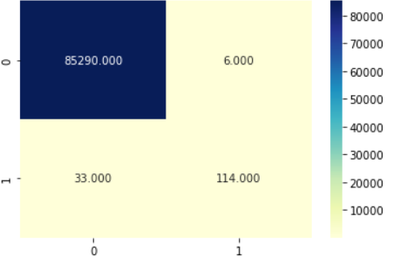

Fig. 9.1.1.1 Confusion matrix for testing dataset

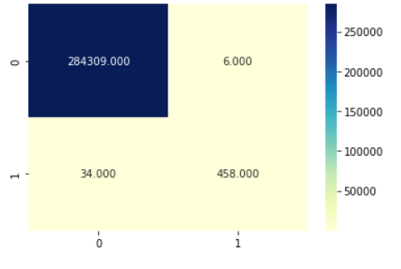

**Fig. 9.1.1.2: Confusion matrix for testing dataset**

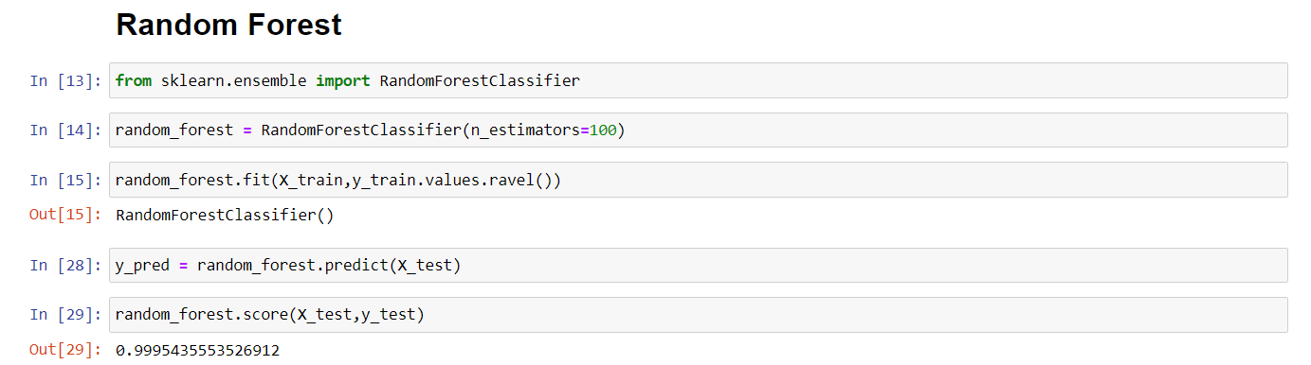

Fig. 9.1.1.3: Accurate result extracted from the random forest

**Chapter – 10**

**CONCLUSION**

Hence, we have acquired the result of an accurate value of credit card fraud detection i.e., **0.9994802867383512 (99.93%)** using a random forest algorithm with new enhancements. In comparison to existing modules, this proposed module is applicable for the larger dataset and provides more accurate results. The Random Forest algorithm will provide better performance with many training data, but speed during testing and application will still suffer. Usage of more pre-processing techniques would also assist. Our future work will try to represent this into a software application and provide a solution for credit card fraud using the new technologies like Machine Learning, Artificial Intelligence and Deep Learning.

**References:**

[1] Sudhamathy G: Credit Risk Analysis and Prediction Modelling of Bank Loans Using R, vol. 8, no-5, pp. 1954-1966.

[2] LI Changjian, HU Peng: Credit Risk Assessment for Ural Credit Cooperatives based on Improved Neural Network, International Conference on Smart Grid and Electrical Automation vol. 60, no. - 3, pp 227-230, 2017.

[3] Wei Sun, Chen-Guang Yang, Jian-Xun Qi: Credit Risk Assessment in Commercial Banks Based on Support Vector Machines, vol.6, pp 2430-2433, 2006.

[4] Amlan Kundu, Suvasini Panigrahi, Shamik Sural, Senior Member, IEEE, “BLAST-SSAHA Hybridization for Credit Card Fraud Detection”, vol. 6, no. 4 pp. 309-315, 2009.

[5] Y. Sahin and E. Duman, “Detecting Credit Card Fraud by Decision Trees and Support Vector Machines, Proceedings of International Multi Conference of Engineers and Computer Scientists, vol. I, 2011.

[6] Sitaram Patel, Sunita Gond, “Supervised Machine (SVM) Learning for Credit Card Fraud Detection, International of engineering trends and technology, vol. 8, no. -3, pp. 137- 140, 2014.

[7] Snehal Patil, Harshada Soma Vanshi, Jyoti Gaikwad, Amruta Deshmane, Rinku Badgujar," Credit Card Fraud Detection Using Decision Tree Induction Algorithm, International Journal of Computer Science and Mobile Computing, Vol.4 Issue.4, April- 2015, pg. 92-95

[8] Dahee Choi and Kyungho Lee, “Machine Learning based Approach to Financial Fraud Detection Process in Mobile Payment System", vol. 5, no. - 4, December 2017, pp. 12-24.

[9] R. Wheeler, S. Aitken, "Multiple algorithms for fraud detection" in Knowledge-Based Systems, Elsevier, vol. 13, no. 2, pp. 93-99, 2000.

[10] S. Patil, H. Somavanshi, J. Gaikwad, A. Deshmane, R. Badgujar, "Credit Card Fraud Detection Using Decision Tree Induction Algorithm", International Journal of Computer Science and Mobile Computing (IJCSMC), vol. 4, no. 4, pp. 92-95, 2015, ISSN ISSN: 2320-088X.

[11] S. Maes, K. Tuyls, B. Vanschoenwinkel, B. Manderick, "Credit card fraud detection using Bayesian and neural networks", Proceedings of the 1st international naiso congress on neuro fuzzy technologies, pp. 261-270, 2002.

[12] S. Bhattacharyya, S. Jha, K. Tharakunnel, J. C. Westland, "Data mining for credit card fraud: A comparative study", Decision Support Systems, vol. 50, no. 3, pp. 602-613, 2011.

[13] Y. Sahin, E. Duman, "Detecting credit card fraud by ANN and logistic regression", Innovations in Intelligent Systems and Applications (INISTA) 2011 International Symposium, pp. 315-319, 2011.

[14] Selvani Deepthi Kavila,LAKSHMI S.V.S.S., RAJESH B “Automated Essay Scoring using Feature Extraction Method “IJCER, volume 7, issue 4(L), Page No. 12161-12165.

[15] S.V.S.S.Lakshmi,K.S.Deepthi,Ch.Suresh “Text Summarization basing on Font and Cue-phrase Feature for a Single Document”, Emerging ICT for Bridging the Future − Volume 2, Advances in Intelligent Systems and Computing, Page No. 537- 542

[16] Y. Sahin, S. Bulkan, E. Duman, "A cost-sensitive decision tree approach for fraud detection", Expert Systems with Applications, vol. 40, no. 15, pp. 5916- 5923, 2013.

[17] Y. Kou, C-T. Lu, S. Sinvongwattana, Y-P. Huang, "Survey of Fraud Detection Techniques", Proceedings of the 2004 IEEE International Conference on Networking Sensing & Control, 2004.

[18] Y. Sahin, E. Duman, "Detecting Credit Card Fraud by Decision Trees and Support Vector Machines", Proceedings of International Multi-Conference of Engineers and Computer Scientists (IMECS 2011), vol. 1, pp. 1-6, Mar. 16-18 2011, ISSN 2078-0966, ISBN 978-988-18210-3-4.